Use this reference to create a custom report in Workday.

This guide will show you how to:
STEP 1: Create a New Report
STEP 2: Share a Report

STEP 1: CREATE A NEW REPORT

- Login into Workday. In the search bar, type “Create custom report”.

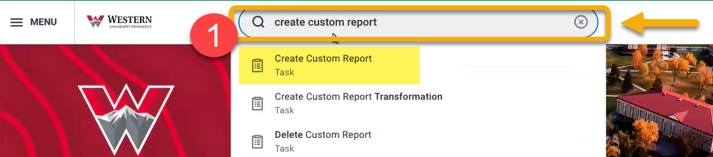

- In the Create Custom Report window, locate the Report Name field and enter the name of your new custom report. TIP: Use descriptive keywords in the report name for easy identification later.

- In the Report Type field, select “Advanced” from the drop-down menu. Advanced reports are list-style reports, which are simple, powerful and helpful for data validation.

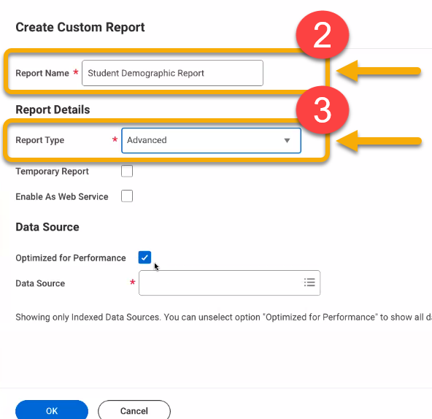

- Under the Data Source heading, locate the Optimized for Performance field and uncheck the box.

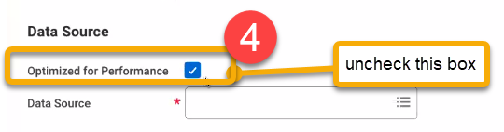

- Locate the Data Source field.
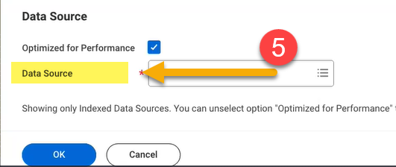
The Data Source field draws from business objects. To select the best option, consider from which business object you wish the data to originate. Below are the four most common selections.

IF YOU WANT… | for example | …THEN | NOTES
Student demographic information… | e.g. legal name, email, address, birthday, race/ethnicity | Select “Students”
Student final or interim grades… | e.g. letter grades | Select “Student Course Registration Record” | This report contains the most recent grades. Alternatively, the more detailed “Student Course Registration” data source contains all grades, interim and final.
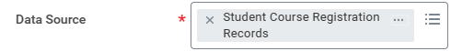
Student academic information from the current academic period… | e.g. program of study, GPA, credits, current course enrollment | Select “Academic Records” | This report will only pull enrolled students from the current academic period
Student academic information from a previous academic period… | e.g. program of study, GPA, past course enrollment, credits | Select “Financial Aid Student Record” | This report pulls from Expected Completion Date therefore, includes new students, continuing students, students not currently registered or in leave of absence. This source has maximum flexibility for the report writer.
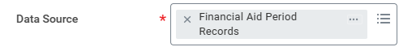
NOTE: While the “Financial Aid Student Record” data source maximizes student data, it does not maximize academic data. So, it must be joined to the academic period report in the upcoming steps.

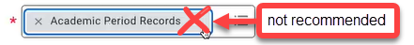
NOTE: For student academic information from a previous academic period, AVOID using the “Academic Period Records” data source because this only includes students who have completed Continuing Student Onboarding or those that have a course registration for that academic period. Only use this data source if you are doing a report where you know students have completed registrations.

- Since we are creating a student demographic report in this example, Data Source: “Students” is selected.

Click “OK”.

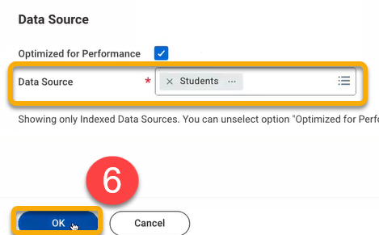

- On the Edit Custom Report page, the required fields often populate automatically. If this is the case with your report, you can revise the Data Source Filter field or leave as is. Most often, it is best not to change it.
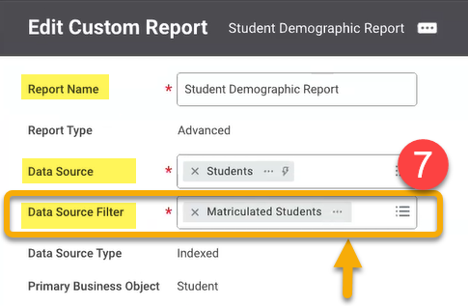

TIP: Sometimes, the Data Source Filter default is not the best choice for your report. Try other selections in this field to make minor adjustments to your final report until you find the best fit for your needs.

- Scroll down and identify the Additional Info heading. This features eight tabs. To build your report, move through the tabs to adjust settings. Only the Columns tab is required. This guide will glance at Columns, Filter, and Prompts tabs. When all settings are set, click “OK” at the bottom of the screen.

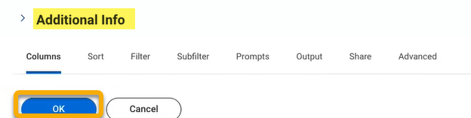

Columns Tab

In this tab, select business objects and the fields from the business objects that you want in the report. In this example, data is pulled from the same business object, “Student”, but that is not always the case.
To add or remove a row, click .
To reorder the rows, click the arrows in the Order column. The final report will reflect the order of this table.
If you want to change the field name in the report, type the custom name in the Column Heading Override field.
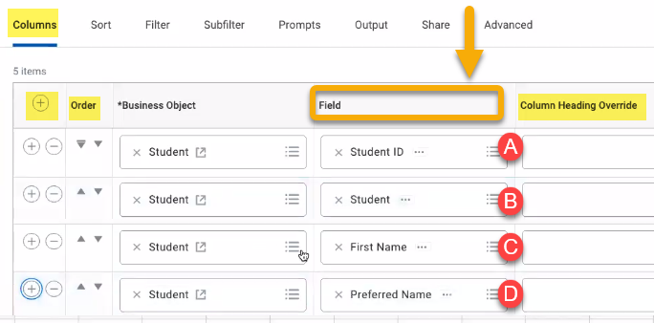

TIP: To enter fields, type keywords and the field will auto-populate with suggestions.

TIP: If you are not sure which field to select, select both and run the report to see the result and make a decision.

- Use Student ID as your unique record identifier. This works better than universal ID.
- The Student field is highly recommended and makes a report interactive. It creates hyperlinks in your report to access more information.
- Note First Name is the legal name
- If you like, include Preferred Name as well
TIPS for the Columns Tab
In the Columns tab users must select fields and business objects to pull data that will be included in a report. Sometimes it is hard to know whether the selections are collecting the intended data. Below are helpful tips for making an accurate report.

If you want to include… | Select Business Object > Field | Description
Student completed hours | Academic Record > Total Completed Hours  -AND-  Academic Record > Transcript Total Transfer Hours | The Academic Record>Total Complete Hours includes only institutional hours at WCU. To include all hours, you must include transfer hours in a separate field.
Student WCU email address | Student > Primary Institutional Email Address | Whenever possible select the field beginning with the word “Primary”.
Student GPA | Academic Record > GPA Cumulative Overall | This includes GPA from WCU and all previous institutions.

Sort Tab

In this tab, you can sort the fields selected in the Columns tab. In this example, the report will sort by last name in alphabetical, ascending order. This tab is optional.

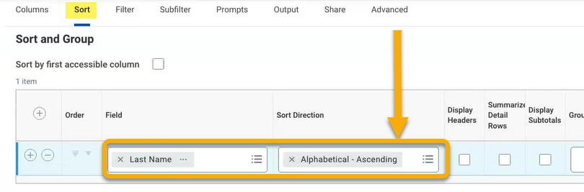

Filter Tab

This tab allows you to filter your results. This is optional.

In this student demographics report, we create a condition that filters by last name as seen in Filter>Last Name and Operator>Equal to. This will result in a report that allows users to display student records with a specified last name.

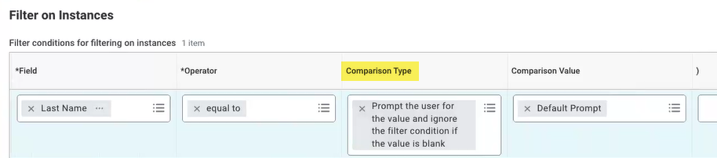

If using a filter, always select Comparison Type > Prompt the user for the value and ignore the filter condition if the value is blank. This is because you can define on the prompt tab if it is required to select or not. If you make it required here and don’t make it required on you prompt page, it can confuse the user.

Prompts Tab

Once you have built your filter, move to the Prompts tab to complete the configuration. The field containing the previously created filter is available in the Field column.

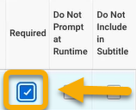
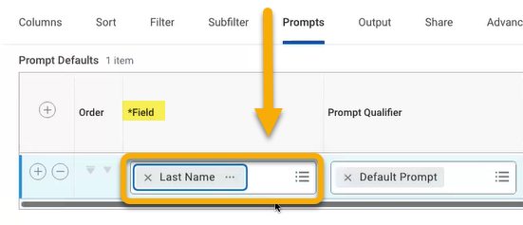

Next, scroll to the far right of the window and select “Required” if you want it to be required. Or leave it blank if you want it optional.

- When all settings are set, click “OK” at the bottom of the screen.
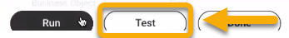
- Before running the report, it is good to test the settings. Click “Test”.

- Your prompts should appear. Just leave them blank for a test and click “OK”.

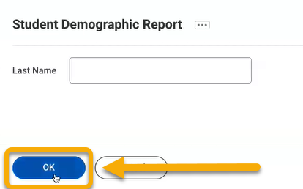

- Review your results.

- If the generated report does not display the information you want, return to the Edit Custom Report page to adjust the Data Source, Data Source Filter, and settings under Additional Info. This step requires some trial and error.
To return to the Edit Custom Report page, click the Related Actions button next to the report title.

- Click “Custom Report”.

- Click “Edit”.

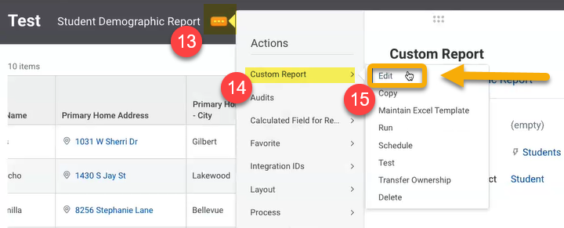

If you are satisfied with the report, click “Run” instead of “Edit”.

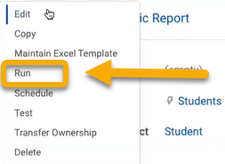
To delete the report, go to the Edit Custom Report page, click the Related Actions button next to the report title. Click “Custom Report” and click “Delete”.

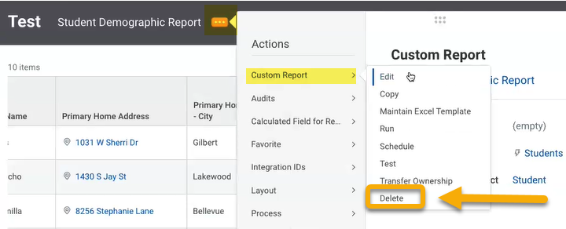

STEP 2: SHARE A REPORT
When you create a new custom report, only you can view and use it. To share your new custom report, follow these steps.

- Return to Edit Custom Report page.

- Below the Additional Info heading, select the Share tab.
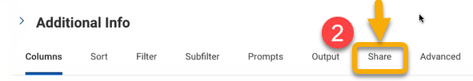

- Complete fields as preferred. In this report example, it is shared with only specific authorized groups and with a specifically named user.

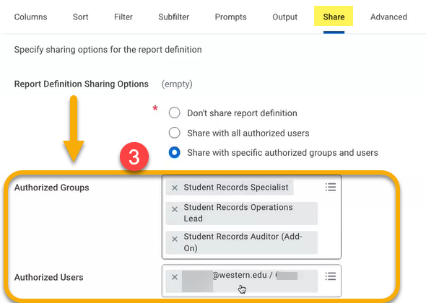
- Lastly, find the Report Tags field near the top of the page. Tag your report so that users can find it easily.
To use an existing tag, type keywords and matches will auto-populate. To create a new tag, click “Create a New Tag”.
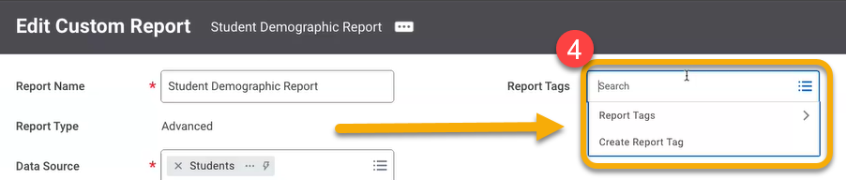

GENERAL TIPS

- When building reports, learn to think backwards.

Before following the steps on this guide, first decide the kind of data you want in the report. Second, identify the business object that contains the data. Third, identify the fields on the business object that contain the data. Fourth, select the corresponding business object and field name in the Columns field.

- Be patient

Expect to run many test reports before landing on the final version. While there are many configuration options to create a fully customized report, the multitude of options slows the process of building the report. Take your time. Remember, reports are also easy to delete.

